**Second Year Section(A)Tutorial(1)**

1. Write a Java application to create Student Profile using suitable layouts as follows: When the user click “Submit” button, all the use input data will be displayed on the TextArea as follows:

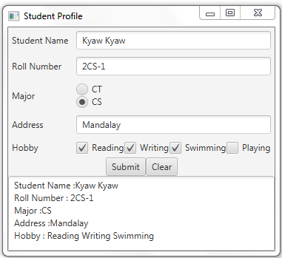

When the user click “Clear” button, all the use input data will be cleared as follows;

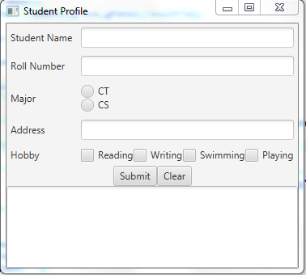

1. (*Demonstrate* ***TextField****properties*) Write a program that sets the horizontalalignment and column-size properties of a text field dynamically, as shown in Figure.

